Colorado River Basin Flow Survey 2014 - Preliminary Results.

Submitted for consideration by the Environmental & Recreational Flows Workgroup.

American Whitewater, Nathan Fey & Evan Stafford

Executive Summary

American Whitewater created this study to help define flows that support the full range of whitewater boating opportunities for the main stem and tributaries of the Colorado River in the Southwestern United States. This survey is designed to inform flow-recreation relationships for targeted river segments in Arizona, New Mexico, Colorado, and Utah.

Information collected in this study is used to develop a quantitative metric for whitewater recreation needs. We have developed this survey so individuals can evaluate flows for each of our targeted whitewater runs, which when compiled describe how flows affect recreation quality, and define the range of flows necessary to support whitewater recreation. The goal is to utilize information from surveys to help quantify flow preferences, identifying low, acceptable, and optimum flows for the range of whitewater recreation experiences, from technical low water to challenging high water trips.

Online surveys segmented by river drainage were completed by a total of 288 respondents. Drainages surveyed were a mix of very popular segments on the main stem of the Colorado River and less popular segments on smaller Colorado River Basin tributaries, including seldom run creeks and segments where whitewater recreation does not occur in all years due to weather patterns and inconsistent in-stream flows.

Overall respondent numbers by drainage survey were consistent with past studies, however certain segments had very low respondent numbers. These stretches generally see less recreation use because of their distance from population centers and irregular flow regimes. Participant comments noted the availability of flows influencing the paddling opportunities these types of runs provide, such as, “The Black Boxes are incredible! But flows are really hard to predict currently.”

Overall response numbers and positive responses to questions about paddling stretches if reliable future whitewater recreational releases occurred, showed high respondent interest and probable future use with enhancement of flows. This information should be considered as potential opportunities and solutions are explored by the workgroup.

For example the White River survey had 42 total respondents, showing good interest in the river, but only 29 respondents had paddled the White and only 20 answered flow related questions, a low response rate. However, 94% of respondents said they would paddle the White River if there were predictable and reliable recreational releases. Many paddler’s who were interested in paddling the White, may not have had the chance to yet because of an unpredictable flow regime, while other respondents may not have been comfortable answering flow related questions due to a lack of experience with the run, or with estimating flows in general.

Both of these scenarios appear to have contributed to low response numbers on at least a few of the segments studied. Time frames for survey responses were also shorter than typical online flow studies, with some studies only receiving responses over a few days (i.e. for the Salt River Survey 38 of 42 responses came over a 3 day period in July 2014), and this may have affected response rates for certain segments. We intend to keep these surveys open and seek out potential groups and even individual respondents, which for the seldom run stretches with inconsistent flows may be the only way to reach targeted response numbers.

Overall most respondents identified themselves as private boaters (94%), while 6% identified as commercial guides and 7% identified as both. Most respondents also identified themselves as experienced paddlers (73% had 10+ years paddling and 81% were advanced or expert paddlers) who check gauges often (91% always or most of the time checked gauges before paddling) and were comfortable estimating flows on familiar rivers and creeks (84% were at least somewhat comfortable).

Impact Acceptability Curves and the Flow Acceptability Agreement Index (Potential for Conflict Index or FAAI) were used to help determine minimum acceptable flows and respondent agreement regarding the acceptability of each specific flow level. This report focuses on developing flow-curves with responses of at least n=10. The sections analyzed found minimum acceptable flows between 300 – 4,000cfs, and these minimum flows generally increase as the segments increase in volume or are frequented more often by rafts. One respondent outlined it as such. “I have run the wilderness section a handful of times in late feb at low flows (250-350) and the day stretch is painfully low at these levels but the rest of the run is great and I will return. To raft the stretch you need lots more water.” In this and in previous studies disagreement over minimum flows can at least partially be attributed to the higher volume flows needed for rafting.

Optimal flow preferences ranged between 400 - 30,000cfs, where for some small creeks optimal flows were lower than minimum flows on the main stem Colorado. Median lowest acceptable, technical, standard, high challenge and highest safe flow were also calculated for the segments analyzed and yielded similar results with 300 – 4,500cfs encompassing the range of minimum acceptable flows. Below each minimum acceptable flow level a significant percent of people would not travel to the river to paddle.

Maximum flow preferences are much harder to quantify due to a significant amount of disagreement between maximum acceptable flows, and due to a majority of respondents reporting no maximum flow (meaning no matter how high the flow gets it’s still acceptable to them to paddle).
Maximum flows ranged between 1800 – 100,000+cfs. The + identifying that for the highest flow levels surveyed on certain segments, on average, none were deemed unacceptable. It is clear from the survey that higher flows are less optimal than somewhat lower flows. At times this may not be due to just to the whitewater being more difficult. “Very high flows wouldn't be dangerous on the water, but would bury some of the great beaches, and camp sites,” according to one respondent. All high flows do have at least some recreational value, as none of the highest flows surveyed for had complete agreement over their unacceptability. One respondent sums it up succinctly. “Ruby-Horsethief doesn't really get all that technical at the flows I've seen. Black Rocks might pose a challenge for canoes at higher levels, but in a cataraft, the higher the better!”

Table 1
Impact Acceptability Curve Minimum, Optimal and Range of Acceptable Flows for
Colorado River Basin Segments
Colorado River Basin Segment | Minimum Flow (CFS) | Optimal Flows (CFS) | Range of Acceptable Flow (CFS)
Cataract Canyon | 4000 | 10000 - 30000 | 4000 – 100000+
Cottonwood Creek | 300 | 500 – 700 | 300 - 2000
Ruby and Horsethief Canyons | 2500 | 4000 – 20000 | 2500 – 50000+
Salt Day Stretch and Wilderness | 700 | 1000 – 2000 | 700 - 10000
San Rafael | 500 | 600 – 900 | 500 - 1800
Tonto Creek | 500 | 800 – 1000 | 500 - 1800
Verde Day Stretch | 300 | 600 – 2000 | 300 - 5000
Westwater Canyon | 2000 | 5000 – 12500 | 2000 – 100000+
White River | 700 | 1000 – 1800 | 700 – 10000+

Table 2
Median Lowest Navigable, Acceptable, Technical, Standard, High Challenge and Highest Safe Flows for Colorado River Basin Segments
Colorado River Basin Segment | Lowest Navigable Flow (CFS) | Lowest Acceptable Flow (CFS) | Technical Flow (CFS) | Standard Flow (CFS) | High Challenge Flow (CFS) | Highest Safe Flow (CFS)
Cataract Canyon | 3000 | 4500 | 4000 | 10000 | 43500 | 50000
Cottonwood Creek | 200 | 300 | 250 | 475 | 1000 | 1000
Ruby and Horsethief Canyons | 1500 | 2500 | 2000 | 5000 | 20000 | 45000
Salt Day Stretch and Wilderness | 550 | 800 | 600 | 1500 | 4000 | 7750
San Rafael | 325 | 425 | 450 | 700 | 1300 | 1500
Tonto Creek | 425 | 550 | 500 | 800 | 2000 | 2000
Verde Day Stretch | 200 | 300 | 300 | 850 | 2100 | 4500
Westwater Canyon | 1500 | 2500 | 2000 | 5500 | 15000 | 30000
White River | 500 | 800 | 600 | 1000 | 3500 | 4500

Figure 1
Flow Acceptability Agreement Index Curve for Cataract Canyon of the Colorado River
(Flows represented are combined flow levels at USGS Colorado River at Cisco, Utah and the Green River near Green River, Utah Gages)
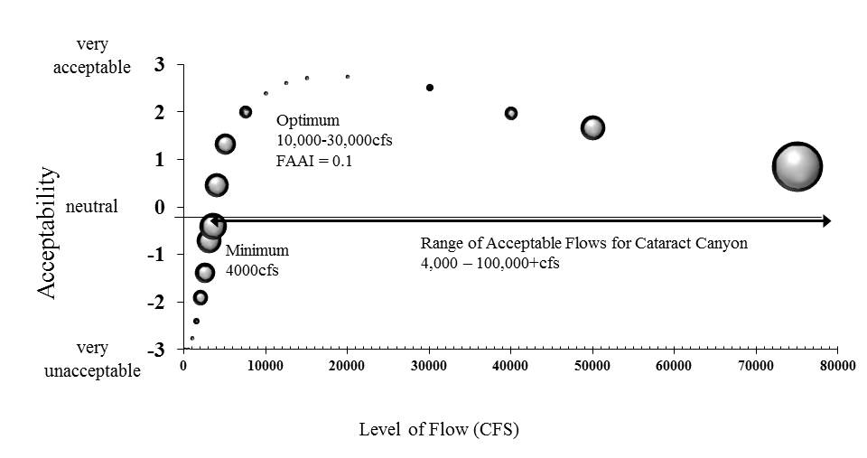

Table 3
Cataract Canyon
Mean Acceptability Scores and Flow Acceptability Agreement Index
(Flows represented are combined flow levels at USGS Colorado River at Cisco, Utah and USGS Green River near Green River, Utah)
Specific Flow CFS | Mean Acceptability | FAAI
100 | -3 | 0
500 | -3 | 0
1000 | -2.76 | 0
1500 | -2.4 | 0.077
2000 | -1.91 | 0.191
2500 | -1.38 | 0.251
3000 | -0.71 | 0.307
3500 | -0.4 | 0.338
4000 | 0.47 | 0.299
5000 | 1.33 | 0.262
7500 | 2 | 0.158
10000 | 2.4 | 0.04
12500 | 2.62 | 0
15000 | 2.72 | 0.047
20000 | 2.75 | 0.046
30000 | 2.52 | 0.089
40000 | 1.98 | 0.164
50000 | 1.67 | 0.306
75000 | 0.86 | 0.633
100000 | 0.45 | 0.816

Figure 2

Flow Acceptability Agreement Index Curve for Cottonwood Creek
(Flows represented are flow levels at Joes Valley Reservoir discharge levels at Emery Water Conservancy District Page)

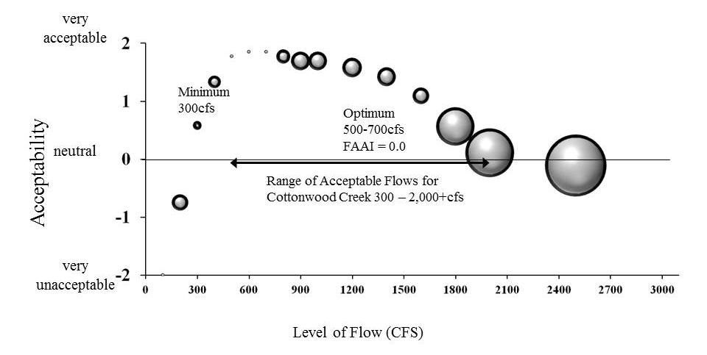

Table 4
Cottonwood Creek
Mean Acceptability Scores and Flow Acceptability Agreement Index
(Flows represented are flow levels at Joes Valley Reservoir discharge levels at Emery Water Conservancy District Page)
Specific Flow CFS | Mean Acceptability | FAAI
100 | -2 | 0
200 | -0.75 | 0.25
300 | 0.58 | 0.132
400 | 1.33 | 0.194
500 | 1.77 | 0
600 | 1.85 | 0
700 | 1.85 | 0
800 | 1.77 | 0.214
900 | 1.69 | 0.286
1000 | 1.69 | 0.286
1200 | 1.58 | 0.299
1400 | 1.42 | 0.285
1600 | 1.09 | 0.25
1800 | 0.56 | 0.588
2000 | 0.11 | 0.75
2500 | -0.11 | 0.95

Figure 3
Flow Acceptability Agreement Index Curve Ruby and Horsethief Canyons
(Flows represented are flow levels at
USGS Colorado River near the Colorado - Utah State Line)
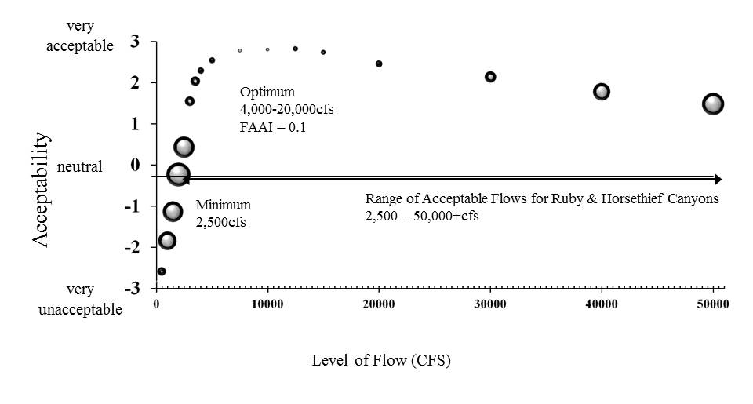

Table 5
Ruby and Horsethief Canyons
Mean Acceptability Scores and Flow Acceptability Agreement Index
(Flows represented are flow levels at
USGS Colorado River near the Colorado - Utah State Line)
Specific Flow CFS | Mean Acceptability | FAAI
100 | -2.85 | 0.035
500 | -2.59 | 0.119
1000 | -1.85 | 0.265
1500 | -1.14 | 0.295
2000 | -0.24 | 0.344
2500 | 0.43 | 0.305
3000 | 1.54 | 0.137
3500 | 2.03 | 0.136
4000 | 2.28 | 0.089
5000 | 2.53 | 0.086
7500 | 2.77 | 0.034
10000 | 2.79 | 0.036
12500 | 2.81 | 0.073
15000 | 2.73 | 0.07
20000 | 2.45 | 0.097
30000 | 2.13 | 0.164
40000 | 1.77 | 0.248
50000 | 1.47 | 0.321

Figure 4
Flow Acceptability Agreement Index Curve for the Salt River
(Flows represented are flow levels at
USGS SALT RIVER NEAR CHRYSOTILE, AZ )
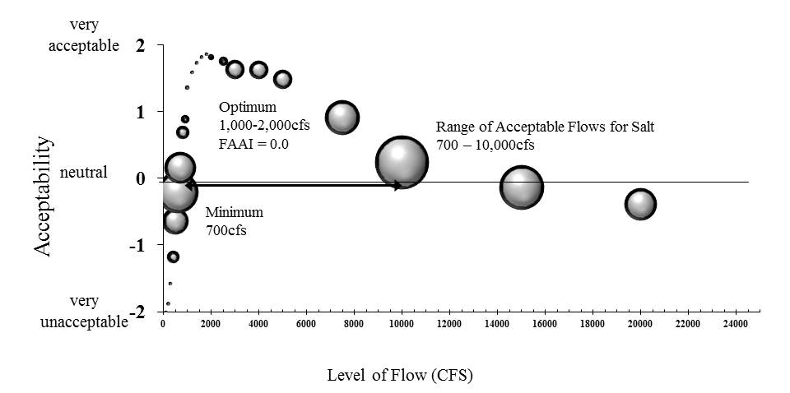

Table 6
Salt River
Mean Acceptability Scores and Flow Acceptability Agreement Index
(Flows represented are flow levels at
USGS SALT RIVER NEAR CHRYSOTILE, AZ )
Specific Flow CFS | Mean Acceptability | FAAI
100 | -2 | 0
200 | -1.87 | 0
300 | -1.57 | 0
400 | -1.17 | 0.169
500 | -0.63 | 0.359
600 | -0.2 | 0.56
700 | 0.17 | 0.439
800 | 0.7 | 0.178
900 | 0.9 | 0.117
1000 | 1.37 | 0.062
1200 | 1.6 | 0
1400 | 1.74 | 0
1600 | 1.83 | 0
1800 | 1.87 | 0
2000 | 1.83 | 0.083
2500 | 1.77 | 0.123
3000 | 1.64 | 0.259
4000 | 1.64 | 0.255
5000 | 1.5 | 0.26
7500 | 0.92 | 0.475
10000 | 0.25 | 0.743
15000 | -0.13 | 0.611
20000 | -0.38 | 0.447
30000 | -0.83 | 0.31
50000 | -0.92 | 0.333
100000 | -1.08 | 0.294

Figure 5
Flow Acceptability Agreement Index Curve for the San Rafael River
(Flows represented are flow levels at USGS SAN RAFAEL RIVER
NEAR GREEN RIVER, UT Gage.)

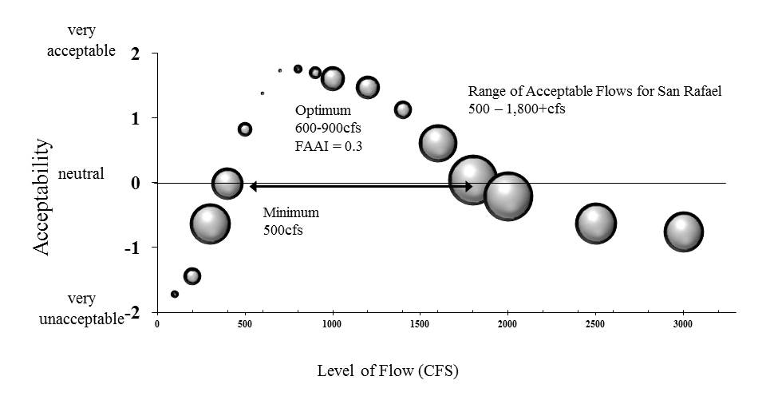

Table 7
San Rafael River
Mean Acceptability Scores and Flow Acceptability Agreement Index
(Flows represented are flow levels at USGS SAN RAFAEL RIVER
NEAR GREEN RIVER, UT Gage.)

Specific Flow CFS | Mean Acceptability | FAAI
100 | -1.71 | 0.11
200 | -1.43 | 0.25
300 | -0.63 | 0.583
400 | 0 | 0.451
500 | 0.83 | 0.205
600 | 1.39 | 0
700 | 1.74 | 0
800 | 1.77 | 0.124
900 | 1.71 | 0.173
1000 | 1.62 | 0.345
1200 | 1.48 | 0.332
1400 | 1.14 | 0.255
1600 | 0.62 | 0.545
1800 | 0.05 | 0.711
2000 | -0.2 | 0.71
2500 | -0.62 | 0.592
3000 | -0.75 | 0.57
4000 | -1 | 0.493

Figure 6
Flow Acceptability Agreement Index Curve for Tonto Creek
(Flows represented are flow levels at USGS TONTO CREEK ABOVE GUN CREEK,
NEAR ROOSEVELT, AZ)

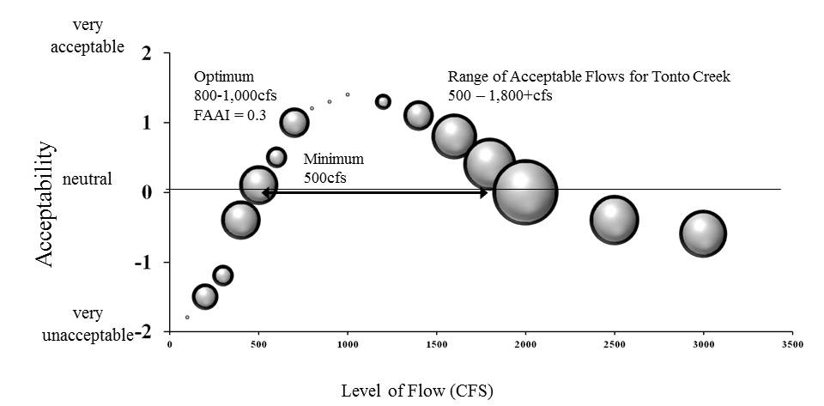

Table 8
Tonto Creek
Mean Acceptability Scores and Flow Acceptability Agreement Index
(Flows represented are flow levels at USGS TONTO CREEK ABOVE GUN CREEK,
NEAR ROOSEVELT, AZ)

Specific Flow CFS | Mean Acceptability | FAAI
100 | -1.8 | 0
200 | -1.5 | 0.35
300 | -1.2 | 0.28
400 | -0.4 | 0.52
500 | 0.1 | 0.52
600 | 0.5 | 0.28
700 | 1 | 0.4
800 | 1.2 | 0
900 | 1.3 | 0
1000 | 1.4 | 0
1200 | 1.3 | 0.21
1400 | 1.1 | 0.4
1600 | 0.8 | 0.6
1800 | 0.4 | 0.7
2000 | 0 | 0.875
2500 | -0.4 | 0.66
3000 | -0.6 | 0.63

Figure 7
Flow Acceptability Agreement Index Curve for Verde River Day Stretch
(Flows represented are flow levels at USGS VERDE RIVER NEAR
CAMP VERDE, AZ Gage)

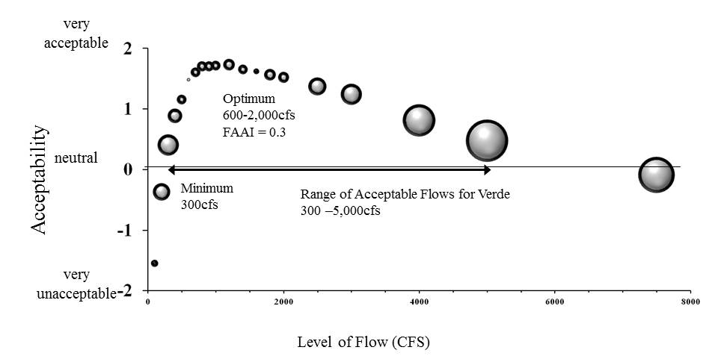

Table 9
Verde River Day Stretch
Mean Acceptability Scores and Flow Acceptability Agreement Index
(Flows represented are flow levels at USGS VERDE RIVER NEAR
CAMP VERDE, AZ Gage)
Specific Flow CFS | Mean Acceptability | FAAI
100 | -1.55 | 0.107
200 | -0.37 | 0.263
300 | 0.4 | 0.323
400 | 0.88 | 0.217
500 | 1.15 | 0.145
600 | 1.48 | 0.05
700 | 1.6 | 0.143
800 | 1.7 | 0.15
900 | 1.7 | 0.149
1000 | 1.71 | 0.146
1200 | 1.73 | 0.1725
1400 | 1.65 | 0.145
1600 | 1.62 | 0.087
1800 | 1.56 | 0.174
2000 | 1.52 | 0.165
2500 | 1.37 | 0.271
3000 | 1.24 | 0.315
4000 | 0.81 | 0.488
5000 | 0.47 | 0.638
7500 | -0.09 | 0.547
10000 | -0.32 | 0.618

Figure 8
Flow Acceptability Agreement Index Curve for Westwater Canyon, Colorado River
(Flows represented are flow levels at
USGS Colorado River near the Colorado - Utah State Line)
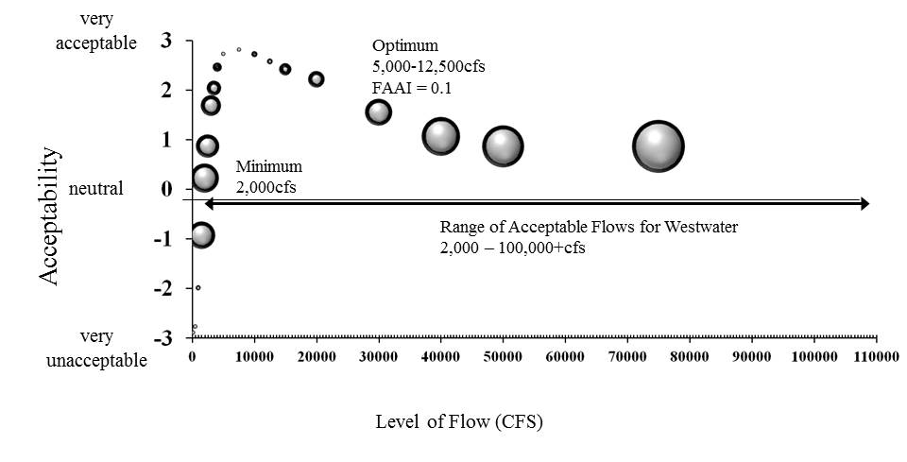

Table 10
Westwater Canyon, Colorado River
Mean Acceptability Scores and Flow Acceptability Agreement Index
(Flows represented are flow levels at
USGS Colorado River near the Colorado - Utah State Line)

Specific Flow CFS | Mean Acceptability | FAAI
100 | -2.89 | 0.053
500 | -2.77 | 0.052
1000 | -1.99 | 0.059
1500 | -0.93 | 0.326
2000 | 0.22 | 0.343
2500 | 0.87 | 0.275
3000 | 1.68 | 0.242
3500 | 2.03 | 0.173
4000 | 2.45 | 0.107
5000 | 2.72 | 0
7500 | 2.81 | 0
10000 | 2.72 | 0.069
12500 | 2.57 | 0.066
15000 | 2.41 | 0.143
20000 | 2.21 | 0.196
30000 | 1.55 | 0.32
40000 | 1.06 | 0.458
50000 | 0.86 | 0.502

Figure 9
Flow Acceptability Agreement Index Curve for the White River
(Flows represented are flow levels at
USGS White River Near Watson, UT )
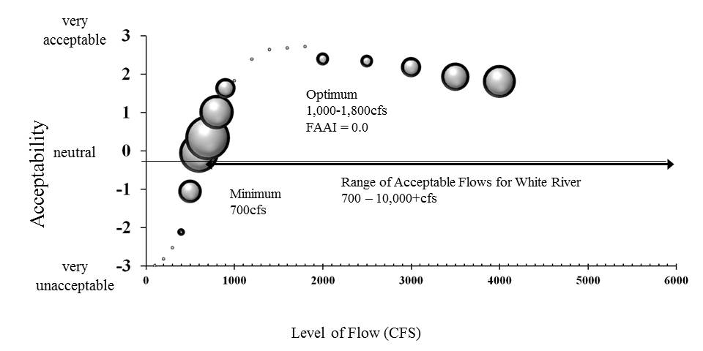

Table 11
White River
Mean Acceptability Scores and Flow Acceptability Agreement Index
(Flows represented are flow levels at
USGS White River Near Watson, UT)
Specific Flow CFS | Mean Acceptability | FAAI
100 | -3 | 0
200 | -2.82 | 0
300 | -2.53 | 0
400 | -2.12 | 0.118
500 | -1.06 | 0.361
600 | -0.06 | 0.609
700 | 0.33 | 0.69
800 | 1 | 0.53
900 | 1.63 | 0.31
1000 | 1.82 | 0
1200 | 2.38 | 0
1400 | 2.63 | 0
1600 | 2.67 | 0
1800 | 2.71 | 0
2000 | 2.39 | 0.2
2500 | 2.33 | 0.198
3000 | 2.17 | 3.09
3500 | 1.92 | 0.437
4000 | 1.8 | 0.509
5000 | 1.53 | 0.539
7500 | 0.71 | 0.626
10000 | 0.53 | 0.699

